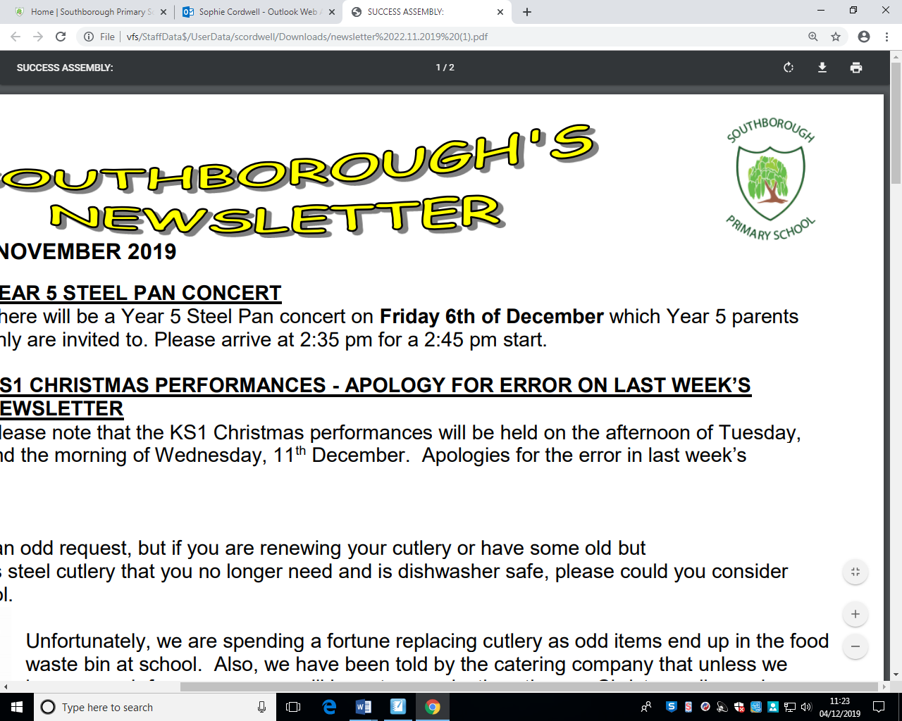

**Art/DT/ICT**

* Create a collage of your favourite things.
* Present any homework activity using a media programme of your choice.

**Others**

* Do 5 minutes of exercise every day.
* Take a photo of yourself doing something different every day for a week.
* Bake some bread.

**Reading**

* Read a book by Marlorie Blackman.
* Read a fiction or non-fiction book of your choice.
* Read a poem by any poet and make a picture of it.
* Read a book on Bug Club.

**Gold Award**  
3 activities from Reading, Writing and Maths and 1 from each of the other boxes.

**Science**

* Make a list of all the different things in your house that use a push or pull force.
* Write a paragraph about why forces are important.

**Bronze Award**

1 activity from each box

**Writing**

* Write a letter to your future self. Include your hopes and dreams for the future.
* Write an alternative ending to a story you have read.
* Cut out a picture of a person, they could be famous or someone you know and write a description of them.
* Help write a shopping list.

**Year 4 – What Happens Inside Us?**

**Due in Wednesday 25th May 2022**

**Topic**

* Make your own digestive system.
* Make a model of your teeth.
* Make a model or picture of a human skeleton.

**Silver Award**  
2 activities from Reading, Writing and Maths and 1 from each of the other boxes.

**Maths**

* Write out 5 word problems that involve negative numbers.
* Use timestable.co.uk and do the practice test at least twice a week and record your score.
* Make a time table of the things you do in a day. Work out how much time you spend at school and at home.
* Spend 10 minutes on Doodle maths each day for a week.
* Earn a certificate on TTRS.