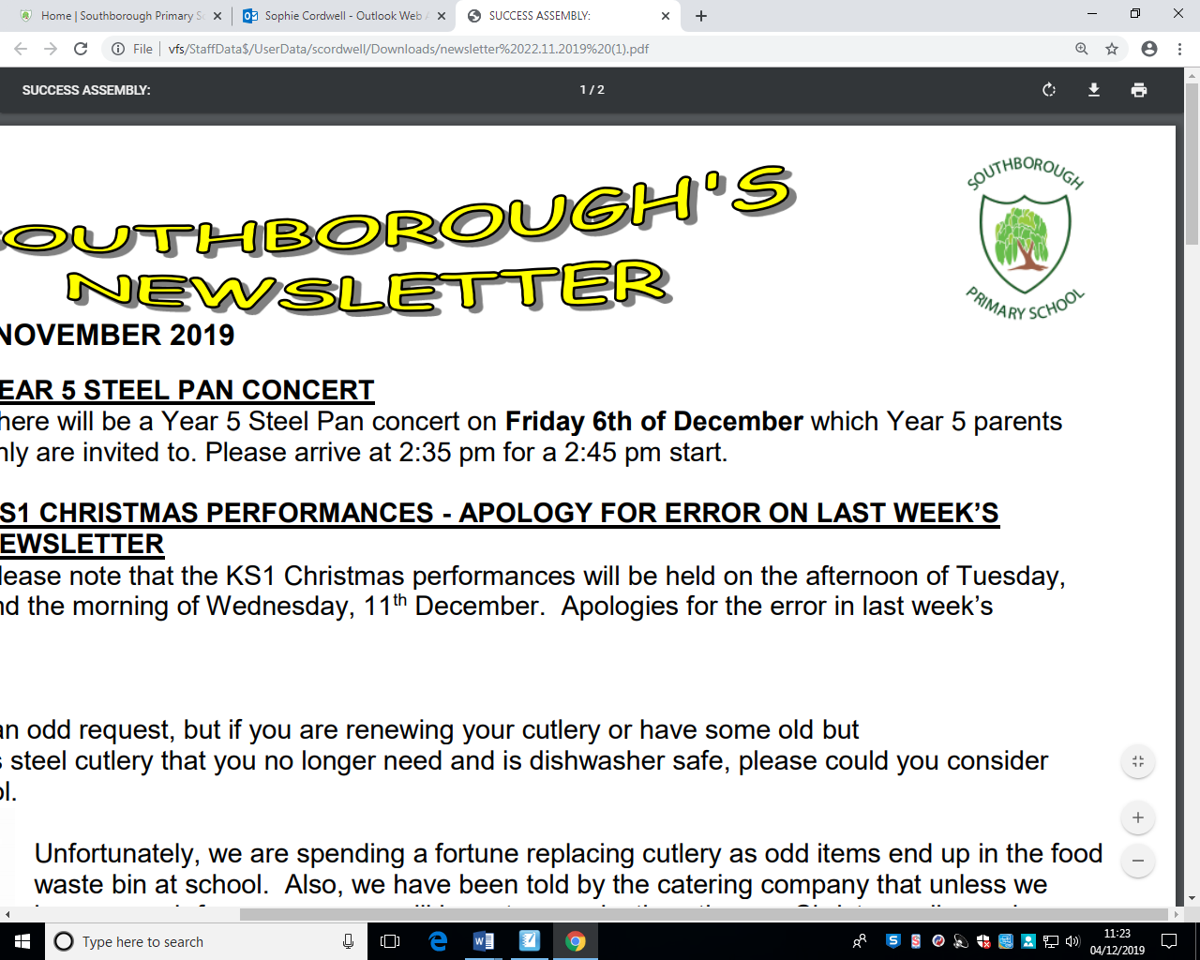

**Reading**

* Read a book by Michael Morpurgo
* Read a fiction or non-fiction book of your choice.
* Read a poem by Dr Seuss and write your own version

**Art/DT/ICT**

* Research Claude Monet and draw a portrait of him.
* Present any homework activity using a media programme of your choice.

**Gold Award**  
3 activities from Reading, Writing and Maths and 1 from each of the other boxes.

**Science**

* Make a poster on solids, liquids and gases.
* Research and describe a scientist of your choice.

**Bronze Award**

1 activity from each box

**Writing**

* Cook a meal and write out a recipe including measurements.
* Write a diary entry about an activity you did at the weekend.
* Write a book review on the book your read by Michael Morpurgo.
* Write a letter to the Education Minister about how school has changed.

**Year 4 – Why do we see, why do we hear?**

**Due in Tuesday 12th October 2021**

**Topic**

* Make a diagram of the eye.
* Explain what shadows are.
* Make a fact sheet sight and sound

**Silver Award**  
2 activities from Reading, Writing and Maths and 1 from each of the other boxes.

**Others**

* Do 5 minutes of exercise every day.
* Help teach a member of your family a new skill.
* Bake a cake.

**Maths**

* Write out 5 word problems that involve either addition, subtraction, multiplication or division
* Learn all of your Times tables (be prepared to be tested)
* Learn to tell the time on a digital and analogue clock
* Earn a bronze, silver or gold award on Mathletics.
* Earn a certificate on TTRS.