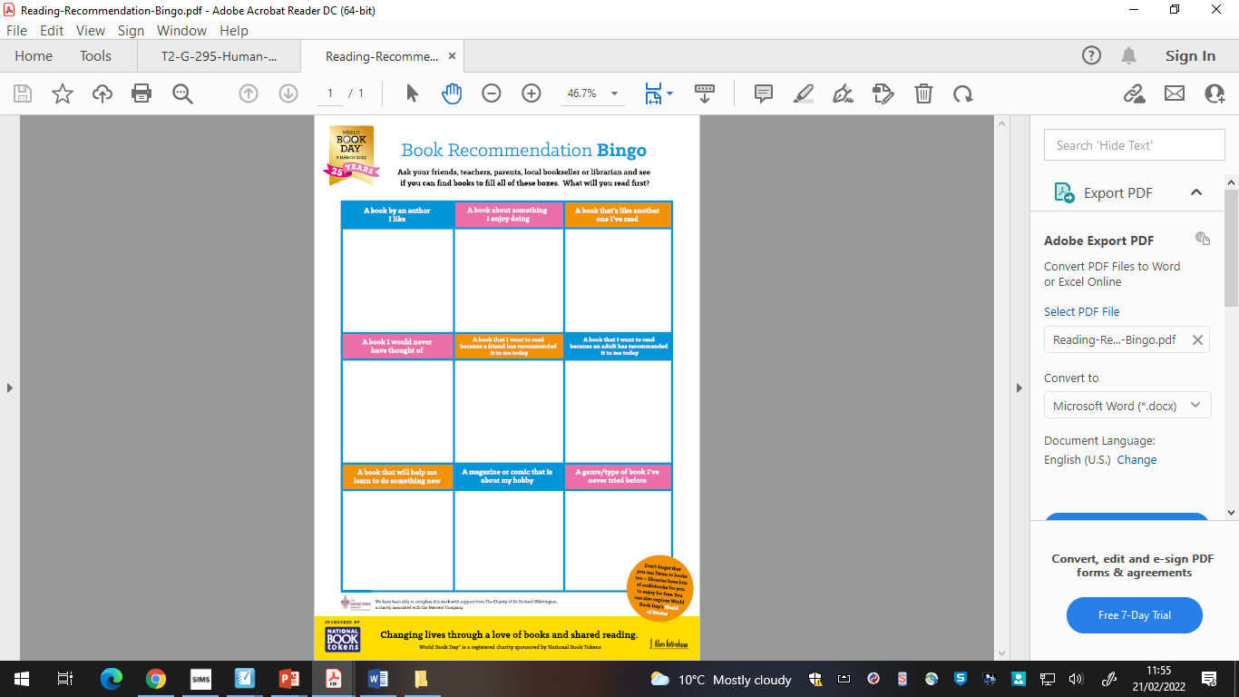

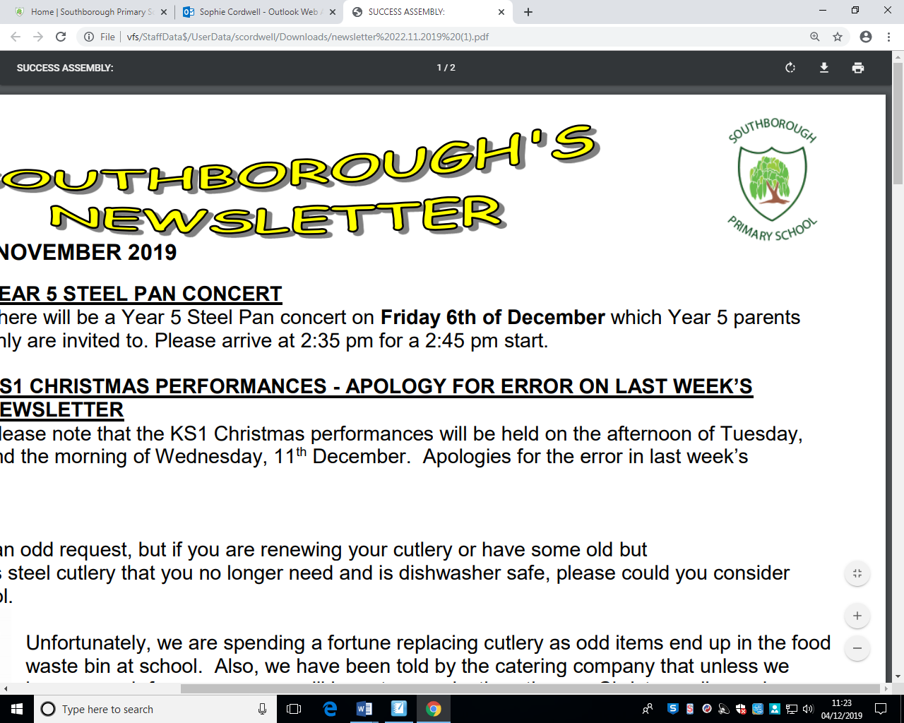

**Art/DT/ICT**

* Use 2publish on Purple Mash to write up your balanced argument.
* Present any homework activity using a media programme of your choice.

**Others**

* Do 5 minutes of exercise every day.
* Design a World Book Day token – entries need to be in by 3rd April.
* Bake some bread.

**Reading**

* Read a book by your favourite author.
* Read a fiction or non-fiction book of your choice.
* Complete “Book Recommendation Bingo” to celebrate World Book Day.
* Read a book on Bug Club.

**Gold Award**  
3 activities from Reading, Writing and Maths and 1 from each of the other boxes.

**Science**

* Make a poster about sugar.
* Make a leaflet or fact file about how you have a balanced diet.

**Bronze Award**

1 activity from each box

**Writing**

* Write a balanced argument on a news event. Have a look at Newsround to help you.
* Write down the books you like and why you like these books.
* Write a book review on the book you have read recently.
* Make a list poem of things in your house.

**Year 4**

**Due in Wednesday 30th March 2022**

**Topic**

* What do you know about the UK? Write down everything you know.
* Find out about a famous landmark in the UK.

**Silver Award**  
2 activities from Reading, Writing and Maths and 1 from each of the other boxes.

**Maths**

* Write out 5 word problems that involve fractions.
* Learn all of your Times tables.
* Use [www.timestable.co.uk](http://www.timestable.co.uk) and have a go at the practise test twice a week.
* Spend 10 minutes on Doodle maths each day for a week.
* Get your class the Doodle certificate of the week by having a go at home.
* Earn a certificate on TTRS.